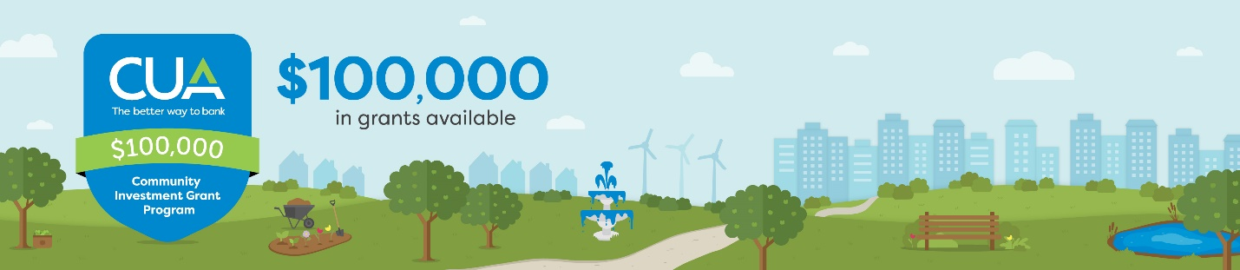
Thank you for submitting your big idea to CUA’s Community Investment Grant Program. We’re excited to hear about your work to strengthen your business, community and the Nova Scotia economy.
As a reminder, applications will be reviewed to ensure alignment with eligibility criteria. The following application contains 33 questions, some of which require open-ended responses. It is recommended that applicants first download this worksheet to finalize responses before proceeding to the application below.
Ready to proceed? Submit your grant request by completing the form below:
*1. How did you hear about CUA’s Community Investment Grant Program? |  | - Social media  - Media coverage  - From a CUA member  - From a CUA employee  - CUA’s website  - CUA’s mobile banking app  - CUA’s newsletter  - Word of mouth  - From a past Program recipient  - By email, I’m a past applicant  - Other: ____________
*2. Please indicate the grant category for which you believe you are best suited (choose one):
- Small Business ($40,000). This category consists of small businesses and social enterprises with a strategic investment of between $1,000 and $10,000 to be used for new equipment, technology, operational design or e-commerce development.

- Sustainability ($20,000). This category supports projects with a measurable impact on the environment, ecosystem and biodiversity. A minimum of two recipients will be in the area of energy efficiency, the reduction of greenhouse gases and/or improved waste management.

- Health and Wellness ($15,000). This category supports programs or initiatives that improve the health and well-being of Nova Scotians, enhancing communities and health outcomes in the areas of financial health, mental health, food security, sport or physical fitness. A minimum of three grant recipients will be selected in this category.

- Community ($15,000). This category is for non-profit organizations and community associations in Nova Scotia, providing grants between $1,000 and $10,000 to invest in a one-time purchase, program or initiative that would otherwise not be possible, enhancing their impact on clients and communities.

- New Business ($10,000). This category is for businesses who have incorporated or started operations in 2020 and will provide between $1,000 and $5,000 to support growth and expansion.
ABOUT YOU
*3. Your Name (Applicant):
*4. Organization or Business Name:
*5. Organization or Business Mailing Address:
*6. What part of Nova Scotia does your organization or business operate in? Does your organization or business operate across Nova Scotia? | - Central Zone (Halifax area, Eastern Shore, West Hants)  - Eastern Zone (Cape Breton, Guysborough and Antigonish areas)  - Northern Zone (Colchester-East Hants, Cumberland and Pictou areas)  - Western Zone (Annapolis Valley, South Shore and South West areas)  - In two or more Zones  - In every Zone across Nova Scotia
*7. Does your organization or business currently operate outside of Nova Scotia? | - Yes  - No
*8. How many years has your organization or business been in operation? | - This is a start-up – in Year 1  - Less than 3  - 3-5  - 6-9  - More than 10
*9. Is your organization a registered business or charity? | - Yes  - No
*10. Email address:
*11. Phone number:
*12. Do you bank with CUA (either personally or for your organization or business)? | - Yes  - No
*13. Are you a member of the Halifax Chamber of Commerce? | - Yes  - No
ABOUT YOUR WORK
14. Project or Initiative Name (if applicable)
*15. Who or what community in NS will benefit most from your project or initiative?
*16. In what location will the project or initiative take place?
*17. How many people will benefit from your initiative? | - 10 or fewer  - 11-50 people  - More than 50 people  - More than 100 people  - More than 1,000 people
*18. Tell us about the project or initiative (250 words):
*19. What is the objective or goal of your project or initiative (250 words)?
*20. When will the funds be used to start the work? | - Q1 2021 (January – March)  - Q2 2021 (April – June)  - Q3 2021 (July – September)  - Q4 2021 (October – November)
*21. Will the project or initiative be completed in 2021? | - Yes  - No
*22. Is your project or initiative a recurring event, festival or program that will require future funding and/or sponsorship? | - Yes  - No
*23. Will the funds be directed toward staffing, administration or operational costs such as rent, payroll, overhead costs, heat, lights, maintenance? | - Yes  - No
*24. How much are you requesting? | - $1,000  - $1,500  - $2,000  - $2,500  - $3,000  - $3,500  - $4,000 |  | - $4,500  - $5,000  - $5,500  - $6,000  - $6,500  - $7,000  - $7,500 | - $8,000  - $8,500  - $9,000  - $9,500  - $10,000
*25. Will the funds you’ve requested cover 100% of the total project cost? | - Yes  - No
26. If “No” above, how much will the total project or initiative cost?
*27. What will the grant funds be used to purchase and/or make possible?
*28. Has your organization or business applied to CUA’s Community Investment Grant Program in the past? | - Yes  - No  - I’m not sure
*29. Has your organization or business received funding through CUA’s Community Investment Grant Program in the past? | - Yes  - No  - I’m not sure
*30. Who will be leading / overseeing the project?
*31. How will you measure success?
*32. Will this project or initiative have a direct impact on the financial health of a person, organization or small business? | - Yes  - No
*33. Please elaborate on the above answer.

